Study 3.10
DRAFT FISH ENTRAINMENT
May 13, 2010 + Agencies preliminary comments 8-9-10

[This study proposal was discussed at the 5/13 Relicensing Participants Study Proposal Development meeting. The changes below are based on the meeting. Follow-up items included: 1) agencies were interested in using acoustic sampling in New Bullards Bar Reservoir to determine if fish are near the intakes. Licensee said there was concern that this was doable at a reasonable cost, would provide useful information, and said it would consult with Fish Pro, a part of HDR that specializes in acoustic regarding feasibility in New Bullards Bar Reservoir for this purpose, as well as data reliability and rough cost. Jim Lynch said he would issue an email in about a month regarding findings, but regardless, Licensee still questioned if the data were needed for a number of reasons discussed at the meeting. Agencies also requested that Licensee assess entrainment at Our House and Log Cabin by 1) installing pit tagging detectors at the intakes with a goal of maximum detection over the entire intake cross section, but at least about 50%; 2) pit tagging about 1,000 fish collected upstream of the intakes (continue sampling and tagging fish upstream as encountered until 1,000 fish tagged and tagging would be in some proportion to fish caught and above a certain (limit of tagging), 3) calibrate the intake detection by releasing tagged hatchery fish in front of the intakes. Agencies to provide more details (e.g., species, size, etc.). At the May 13 meeting, Licensee said it thought this approach, instead of the one proposed by Licensee, seemed too aggressive (felt that pit tagging at the intakes would be problematic due to the size of the intakes and the metal trashracks, not sure why tagging fish such as sculpin is useful, and felt Licensees radio-tagging along with the fish population data to be collected would be a good starting point before implementing such an aggressive approach. It was agreed to come back to this at a future meeting. JML 5/12]

1.0 Project Nexus

Yuba County Water Agency’s (YCWA or Licensee) continued operation and maintenance (O&M) of the existing Yuba River Development Project (Project) has a potential to affect fish due to entrainment into Project intakes.

2.0 Resource Management Goals of Agencies with Jurisdiction over the Resource to be Studied

[Agencies – Section 5.11(d)(2) states that an applicant for a new license must in its proposed study “Address any known resource management goals of the agencies or Indian tribes with jurisdiction over the resource to be studied.” If each agency provides to YCWA a brief written description of their jurisdiction over the resource to be addressed in this study, YCWA will insert the brief description here/or attach it stating the description was provided by that agency. If not, prior to issuing the PAD, YCWA will describe to the best of its knowledge and understanding the management goals of each agency that YCWA believes has jurisdiction over the resource addressed in this study. YCWA] [At 5/12 meeting, agencies said they might provide a single write-up for all study proposals that covers all agencies. Licensee said it would discus the write-up with Relicensing Participants when received, but said Licensees might add to Section 2 in some study proposals what it believed to be key information (e.g., noting USFWS ESA jurisdiction for ESA-listed fishes, and the SWRCB’s jurisdiction over water quality vis-à-vis the Basin Plan. Licensee 5/12]

3.0 Existing Information and Need for Additional Information

The Project includes 10 locations where a Project facility diverts water from a stream or reservoir to another location. Based on existing information, some of these intakes have a low potential to affect fish populations. For other project intakes, additional data gathering is needed to assess potential effects on fish populations. The sections below describes for each intake, the type of intake, the potential for entrainment effects on fish populations, and proposed entrainment related data gathering.

3.1 Intakes for which No Additional Data Gathering Is Proposed

3.1.1 Project Dam Low-Level Intakes/Outlets NOTE: ADD SONAR

The Project includes five dam low-level intakes, each of which is described in Table 3.1-1. These are: 1) Our House Diversion Dam low-level intake; 2) Our House Diversion Dam auxiliary low-level intake; 3) Log Cabin Diversion Dam low-level intake; 4) Log Cabin Diversion Dam auxiliary low-level intake; and 5) New Bullards Bar Dam low-level intake. In each case, the low-level intake is at or near the bottom of the impoundment.

Only two of the low-level intakes, the low-level outlets at Our House and Log Cabin diversion dams, are routinely used (almost always in the fully open position to meet instream flow requirements). The other three low-level intakes are used in emergencies or if otherwise needed (e.g., during repairs of the low-level intake, or infrequent major outages). [In the next draft, License will insert information regarding normal water level fluctuations in the reservoirs. Licensee 5/12]

Table 3.1-1. Description of Project’s five low-level intakes.
Intake  Structure  (From/To) | Conduit  Size | Control  Valve/Gate | Existing  Minimum  Release | Estimated  Maximum  Capacity at Full Pool
Intake  Structure  (From/To) | (inches) | (type) | (cfs) | (cfs)
MIDDLE YUBA RIVER
Our House Diversion Dam  Low-Level Intake  (Our House Diversion Dam Impoundment/Middle Yuba River Immediately Downstream of the Dam) | 24 in  diameter | Downstream Gate Valve Operated Manually | 30 cfs from June 16 through April 14 and 50 cfs from April 15 through June 15, or natural inflow into Our House Diversion Dam Impoundment, whichever is less. | 60 cfs.  Minimum instream flow releases are normally made through this valve unless dam spill meets the minimum flow requirement.
Our House Diversion Dam  Auxiliary Low-Level Intake  (Our House Diversion Dam Impoundment/Middle Yuba River Immediately Downstream of the Dam) | 72 int  diameter | Upstream Slide Gate Operated Manually by a Motor On-Site |  | 800 cfs.  Used for emergencies only.
OREGON CREEK
Log Cabin Diversion Dam  Low-Level Intake  (Log Cabin Diversion Dam Impoundment/Oregon Creek Immediately Downstream of the Dam) | 18 in  diameter | Downstream Gate Valve Operated by Hand | 8 cfs from June 16 through April 14 and 12 cfs from April 15 through June 15, or natural inflow into Log Cabin Diversion Dam Impoundment, whichever is less. | 13 cfs. Minimum instream flow releases are normally made through this valve unless dam spill meets the minimum flow requirement.
Log Cabin Diversion Dam  Auxiliary Low-Level Intake  (Log Cabin Diversion Dam Impoundment/Oregon Creek Immediately Downstream of the Dam) | 72 in  diameter | Upstream Slide Gate Operated by a Motor by a Motor On-Site |  | 800 cfs.  Used for emergencies only.
NORTH YUBA RIVER
New Bullards Bar Dam  Low-Level Intake  (New Bullards Bar Reservoir/North Yuba River Immediately Downstream of the Dam) | 72 in  diameter | Downstream Hollow Jet Valve Operated Remotely | 5 cfs at all times. | 3,500 cfs but actual maximum capacity is 1,250 cfs due to valve vibration. Minimum instream flow releases are normally made through the New Bullards Minimum Flow Powerhouse.

The spacing (i.e., opening between bars) in the trash racks in front of Our House and Log Cabin low-level intakes is 8.75 inches. The spacing in the trash racks in front of Our House and Log Cabin auxiliary low-level intakes is 12.375 inches. The spacing in the trash rack in front of the New Bullards Bar Dam Low-Level Intake is 5.0 inches.

A transition fishery occurs in the vicinity Our House Diversion Dam. As described in Section 7.3.4.1 of the Preliminary Information Package (YCWA 2009), 2004 snorkeling surveys in the Middle Yuba River about 0.5 mile upstream of Our House Diversion Dam found rainbow trout (Oncorhynchus mykiss) and Sacramento pikeminnow/hardhead (Ptychocheilus grandis/Mylopharodon conocephalus) (the snorkelers were unable to distinguish between the two species); while about 0.5 mile downstream of the dam, the snorkelers found rainbow trout, Sacramento pikeminnow, hardhead, smallmouth bass (Micropterus dolomieui), and various sucker species (Family Catastomidae) (Gast et al. 2005). The general species composition upstream of the dam was confirmed by Nevada Irrigation District (NID) is 2008 and 2009 when its snorkeling surveys in the Middle Yuba River about 0.5 mile upstream of Our House Diversion Dam found Sacramento suckers, rainbow trout, and Sacramento pikeminnow (NID and PG&E 2010). NID did not find any hardhead, a California Department of Fish and Game (CDFG) Species of Concern and Forest Service Sensitive Species, in its sampling. CDFG does not stock fish in this area of the Middle Yuba River.

Licensee was unable to find any existing information regarding the fish community in Oregon Creek near Log Cabin Diversion dam, but the fish community is likely similar to that at Our House Diversion Dam. CDFG does not stock fish in Oregon Creek.

While Licensee was unable to find any recent fish studies of New Bullards Bar Reservoir, CDFG fish stocking records are very informative. The reservoir has a long history of annual fish stocking activities dating back to 1959 (Central Valley Fish Hatchery 1959; CDFG 1974). Between 1969 and 2007, about 5 million kokanee salmon (O. nerka), nearly 1.6 million rainbow trout, just over 310,000 Eagle Lake rainbow trout, 40,000 brook trout (Salvelinus fontinalis), 200 eastern brook trout, 200 cutthroat trout (Salmo aquabonita), Kamloop rainbow trout, and 185 spotted bass (Micropterus punctulatus) were planted in New Bullards Bar Reservoir by CDFG (CGFG 1989, 2007). Besides these fishes, sport fishermen report catching in the reservoir largemouth bass (M. salmoides), smallmouth bass, redear sunfish (Lepomis microlophus), crappie (Pomoxis sp.), bluegill (L. macrochirus) and channel catfish (Ictalurus punctatus).

Based on the above information, the potential affects to fish populations due to possible entrainment into one of more of the above low-level intakes is low. No fishes listed as endangered or threatened under the federal Endangered Species Act (ESA) or California Endangered Species Act (CESA) are potentially affected, and hardhead, a California Species of Concern and Forest Service Sensitive Species, may or may not be affected: Gast et al. (2005) reported possible observing some in 2004 but NID did not find any in 2008 and 2009. Further, with regards to the New Bullards Bar Dam low-level intake, the potential for fish to be entrained during its infrequent use is low because the intake is located at elevation 1,447.7 ft in the reservoir, over 508 feet below the reservoir surface at full pool (El. 1,956 ft), where fish normally do not congregate.

.

3.1.2 Project Power Diversions

The Project includes three water diversions, each of which terminates at a powerhouse or a powerhouse bypass.?????? These are 1) New Bullards Minimum Flow Powerhouse Penstock, 2) New Colgate Power Tunnel and 3) Narrows 2 Powerhouse Penstock. Table 3.1-2 provides information regarding the conduits, and Figures 3.1-1 and 3.1-2 and 3.1-3 show the amount of water diverted by each structure in representative normal, wet and dry water years. Figure 3.1-1 shows the New Colgate Power Tunnel Intake portals.
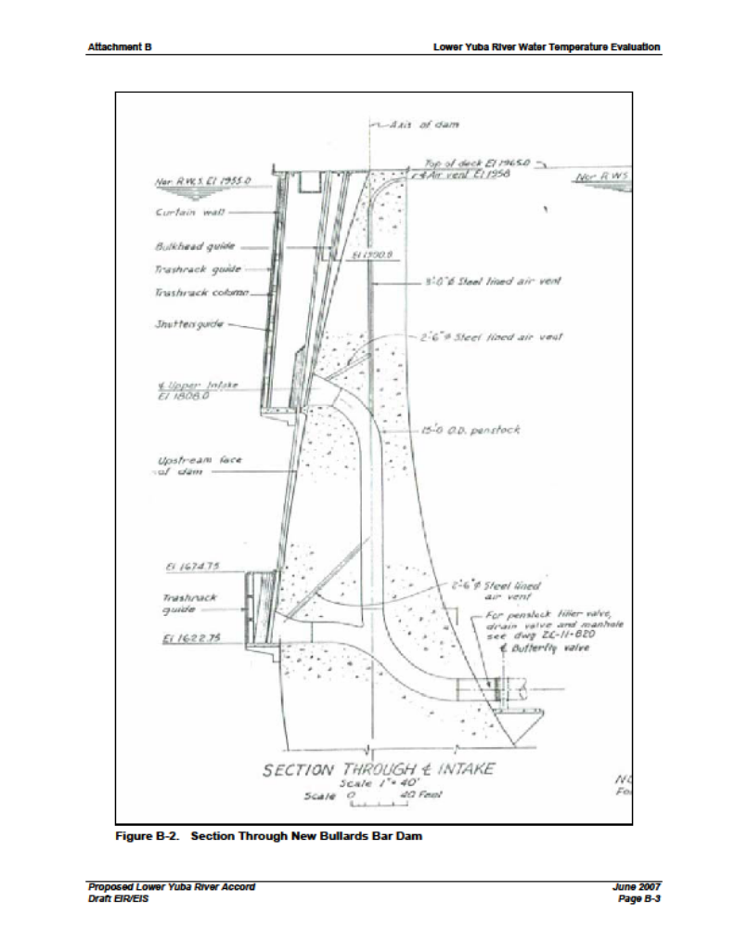
Figure 3.1-1. New Colgate Power Tunnel Intake. [All – We added this after the 5/12 meeting and will clean it up before the PAD is filed Licensee 5/12]
Table 3.1-2. Description of Project power diversions.
Intake  Structure  (From/To) | Conduit  Description | Turbine Number and Type/Bypass Control Valve or Gate | Depth of  of Intake Invert  at Full Pool | Existing Minimum  Release | Estimated  Maximum  Capacity
Intake  Structure  (From/To) | (type & size) | (# and type) | (feet) | (cfs) | (cfs)
NORTH YUBA RIVER
New Bullards Bar Minimum Flow Powerhouse Penstock  (New Bullards Bar Reservoir/North Yuba Rive at base of New Bullards Bar Dam) | 70-foot long, 12 in diameter steel pipe | 1 Pelton Turbine/  No Powerhouse Bypass | 508.5 ft deep  (El, 1,447.5 ft as compared to full pool at El. 1,956 ft), | 5 cfs at all times | 6 cfs
New Colgate Power Tunnel and Penstock  (New Bullards Bar Reservoir/  Yuba River) | 5.2 miles long and composed of four different types of conveyance structures: an unlined horseshoe tunnel 26 feet square; an lined horseshoe tunnel 20 feet wide and 14.5 feet high; a lined circular tunnel 14 feet in diameter; and 2,809 feet of steel penstock with a diameter ranging from 9 feet to 14.5 feet. | 2 Pelton Turbines/  No Powerhouse Bypass | Two openings in intake structure: deeper opening is 336 ft deep  (El, 1,620 ft as compared to full pool at El. 1,956 ft)  and  upper opening is 148 ft deep  (El, 1,808 ft as compared to full pool at El. 1,956 ft) | 5 cfs at all times | 3,500 cfs
YUBA RIVER
Narrows 2 Powerhouse Penstock  (USACE’s Englebright Reservoir/Yuba River about 200 ft downstream of base on USEACE’s Englebright Dam) | 748 ft long composed of two sections: the first is a 376-ft long section 20 feet in diameter and concrete lined, and the second is a 372- ft long section 14 feet in diameter and steel lined. | 1 Francis Turbine/  Two Powerhouse Bypasses: 1) a 78-inch diameter fixed cone valve; and 2) a 36-inch diameter bypass valve. | 86 ft deep  (El. 439.0 ft as compared to full pool at El. 525 ft) | Downstream of Narrows 1 and 2 Powerhouses:¹  Oct 16–10: 600–1,050 cfs  Nov: 600-700 cfs  Dec: 600-1,400 cfs  Jan 1-15: 1,000-1,850 cfs | 3,400 cfs through the Powerhouse, 3,000 cfs through the 78 inch Bypass Valve, and 650 cfs through the 36 inch Bypass Valve
¹ The Project FERC license includes a ramping rate below USACE’s Englebright Dam (Article 33(f), and minimum flows requirements downstream of USACE’s Daguerre Point Dam (Article 33(d).

Licensee has not used the upper gate on the New Colgate Power Tunnel and Penstock Intake since 1993 when Licensee convened a Temperature Advisory Committee to obtain more-refined recommendations for the operation of New Bullards Bar Reservoir’s multilevel outlet. The committee was composed of Licensee, United States Fish and Wildlife Service (USFWS), and CDFG. After reviewing temperature model data and the operating options, USFWS and CDFG recommended that water releases from New Bullards Bar Reservoir be as cold as possible at all times. Licensee immediately implemented this recommendation and, since 1993, all controlled releases of water from New Bullards Bar Reservoir through New Bullards Bar Minimum Flow Powerhouse into the North Yuba River and through New Colgate Powerhouse into the Yuba River have been from the lower intake, which withdraws water from the coldest, deepest part of the New Bullards Bar Reservoir.

The spacing (i.e., opening between bars) in the trash racks in front of the New Bullards Bar Minimum Flow Powerhouse Penstock Intakes is 5.00 inches, and the spacing in the trash racks in front of the New Colgate Power Tunnel and Penstock Intake is 2.25 inches. The spacing in front of the Narrows 2 Powerhouse Penstock Intake is 4.1875 inches.

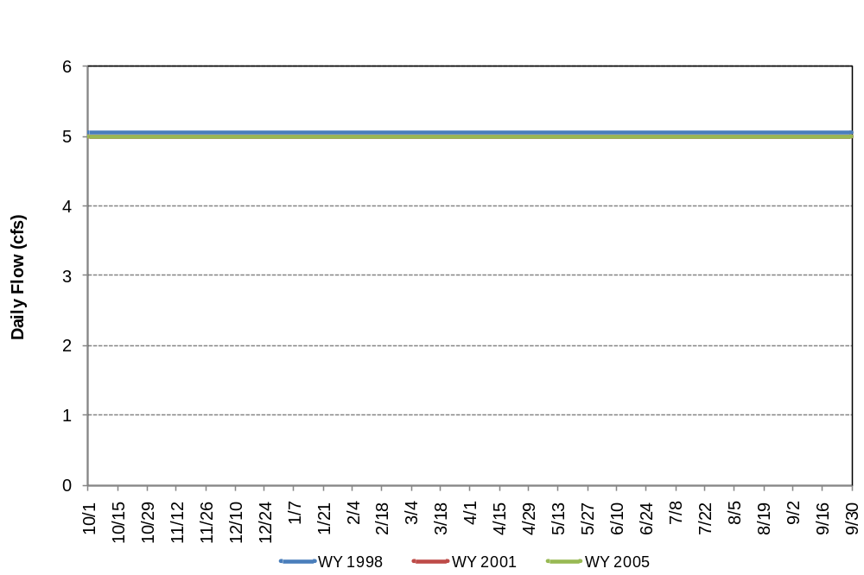
Figure 3.1-1. Mean Daily flow through New Bullards Minimum Flow Powerhouse Penstock in representative Normal (2005), Wet (1988? or 1998?) and Dry (2001) water years. (Recorded data?)

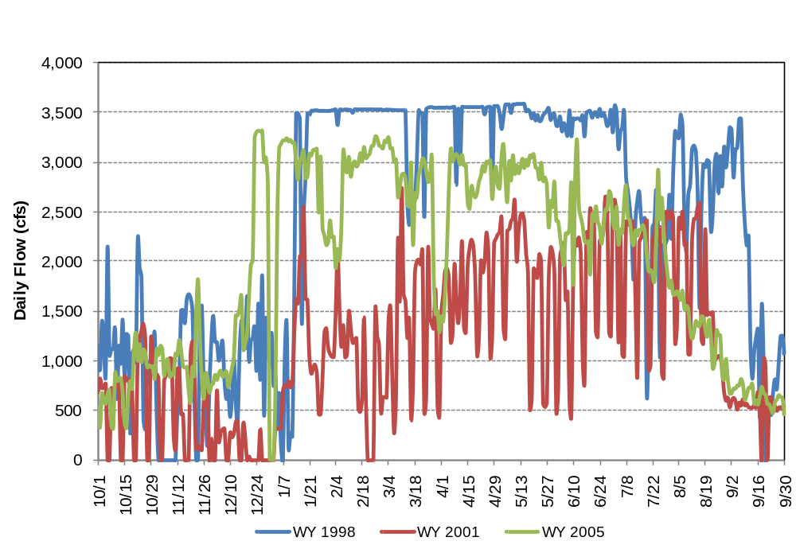
Figure 3.1-2. Mean daily flows through New Colgate Power Tunnel in representative Normal (2005), Wet (1988? or 1998?) and Dry (2001) water years.

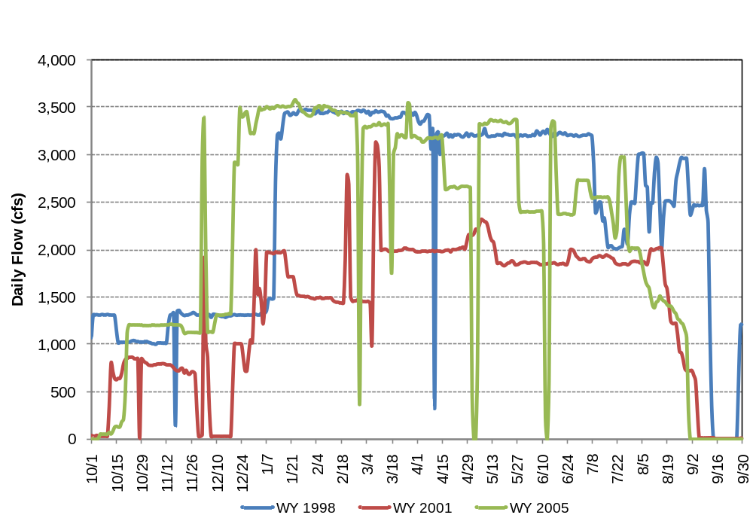
Figure 3.1-3. Mean dialy flows through Narrows 2 Powerhouse Penstock in representative Normal (2005), Wet (1988? or 1998?) and Dry (2001) water years.

Included in Figure 3.1-3 is combined flow through the two Narrows 2 Powerhouse bypasses and the powerhouse. The 36-inch diameter valve was included in the original powerhouse design and the 78-inch diameter valve was added in 2007 to provide the capability to bypass flows of up to 3,000 cubic feet per second (cfs) around the Narrows 2 Powerhouse during times of full or partial powerhouse shutdown. Use of the bypass valves vary by year. Prior to installation of the 72-inch diameter valve in 2007, the 36-inch diameter valve was used for 34 days in 2005 (average flow of 103 cfs) and 15 days in 2006 (130 cfs). Since 2006, the two bypass valves were used, either separately or in combination, for 89 days in 2007 (combined average flow of 695 cfs), 166 days in 2008 (177 cfs) and 201 days in 2009 (193 cfs).

As described above, fish population data is limited but information available at this time identifies the fish community in New Bullards Bar Reservoir as a stocked fishery composed of kokanee salmon, rainbow trout, Eagle Lake rainbow trout, brook trout, eastern brook trout, cutthroat trout, Kamloop rainbow trout and spotted bass. Other fishes known to occur in the reservoir include largemouth bass, smallmouth bass, red ear sunfish, crappie, bluegill sunfish and channel catfish.

Like for the fishery in New Bullards Bar Reservoir, Licensee was unable to find any recent fish population studies in the Englebright Reservoir, but CDFG fish stocking records are very informative. As with New Bullards Bar Reservoir, the Englebright Reservoir has a long history of annual fish stocking activities dating back to 1959 (Central Valley Fish Hatchery 1959; CDFG 1974). CDFG stocking records indicate that fish plantings in Englebright Reservoir have taken place from 1965 through 2007. During this period, just over 756,000 rainbow trout, 228,320 kokanee salmon, 6,973 lake trout, nearly 28,000 brown trout (Salmo trutta), 4,000 Eagle Lake rainbow trout, 2,640 brook trout, 45 white crappie (Pomoxis annularis), and 80 black crappie (P. nigromaculatus) were planted (CDFG 2007). Stocked species were primarily from the Shasta and San Joaquin hatcheries.

Based on the above information, the potential affects to fish populations due to entrainment into one of more of the above power tunnels intakes is low. First, the native fish populations that would be affected are primarily stocked fish used to support a put-and-take fishery. There are no reported occurrences of special-status, ESA-listed or CESA-listed fishes in the reservoirs. Second, the intakes occur deep in each reservoir where it is unlikely that fish congregate. However, fish population assessments have not been conducted to identify the species and age classes of this reservoir community.

Given the low potential to entrain fish and since the fish populations potentially affected are not known to include special-status, ESA-listed or CESA-listed fishes and the reservoirs support a put-and-take fishery, no additional data gathering regarding entrainment effects at the Project’s three power intakes is proposed at this time.

3.2 Intakes for which Additional Data Gathering Is Proposed

3.2.1 New Bullards Bar and USACE’s Englebright Reservoir

delete this comment - [Gabe – Insert wording here that we don’t propose specific entrainment monitoring but the Reservoir Fish Populations Study netting will provide useful information. FYI – need to say in the section below that the Stream Fish Populations Study info will provide fish populations data upstream and downstream of the impoundment, which will provide useful information as well. Be sure to add that sampling to the fish pops study. Thanks. JML 5/13] ???

3.2.1 Project Non-Power Diversion Intakes

The Project includes two non-power diversions intakes: 1) Lohman Ridge Tunnel; and 2) Camptonville Diversion Tunnel. Both diversions are from small impoundments (<200 acres), and the water conduits are composed entirely of underground tunnel except in the immediate vicinity of the intake and outlet where the tunnel daylights. Table 3.2-1 provides information regarding the conduits, and Figures 3.2-1 and 3.2-2 show the amount of water diverted by each structure in representative normal, wet and dry water years. Since flow into the tunnels was not gaged prior to Water Year 1989, the 1988 data in Figures 3.2-1 and -2 are the result of a synthesis.

Table 3.2-1. Description of Project’s non-power diversion intakes.
Intake  Structure  (From/To) | Dimensions  and  Type | Intake  Structure | Outlet  Structure | Estimated  Maximum  Capacity
Intake  Structure  (From/To) | (feet and type) | (type) | (type) | (cfs)
MIDDLE YUBA RIVER
Lohman Ridge Diversion Tunnel Intake  (Our House Diversion Dam Impoundment on Middle Yuba River/Log Cabin Diversion Dam Impoundment on Oregon Creek) | 12.5 ft high by 12.5 ft wide, 19,410 feet (90% unlined and 10% lined) Tunnel | 15 ft high by 12 ft wide concrete structure with a trash rack and slide gate operated manually by a motor on-site | 15 ft high by 12 ft wide concrete structure: no control or enclosure (e.g., rack or fence) | 860 cfs
OREGON CREEK
Camptonville Diversion Tunnel Intake  (Log Cabin Diversion Dam Impoundment on Oregon Creek/New Bullards Bar Reservoir on North Yuba River) | 6,107 ft Tunnel. First 4,275-ft section is an unlined, horseshoe tunnel 14.5 ft wide by 14.5 ft high, and the second 1,832-ft section is a lined 11.7 ft wide by 13 ft high horseshoe tunnel. | 14.5 ft high by 14.5 ft wide concrete structure with a trash rack and slide gate operated manually by a motor on-site | 13 ft high by 11.7 ft wide concrete structure: no control or enclosure (e.g., rack or fence) | 1,100 cfs  (Includes direct diversion of natural flow in Oregon Creek and re-diversion of water from Middle Yuba River through Lohman Ridge Diversion Tunnel into the Log Cabin Impoundment.)

The spacing (i.e., opening between bars) in the trash racks in front of the Lohman Ridge and Camptonville diversion tunnel intakes is 10.625 inches and 11.0 inches, respectively.

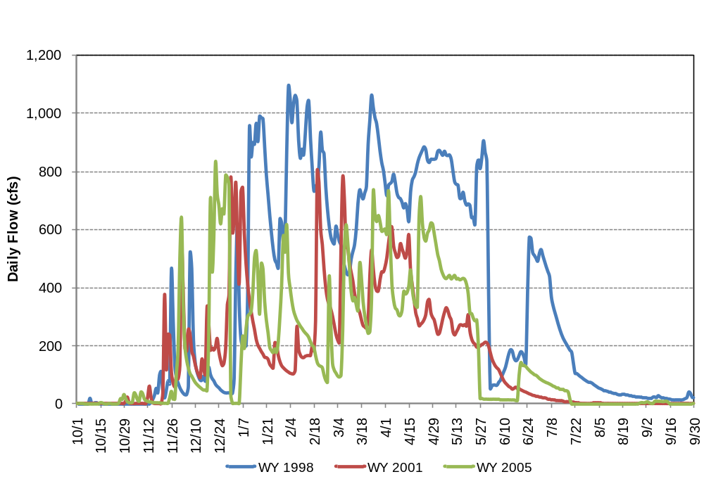
Figure 3.2-1. Mean daily flows in Lohman Ridge Diversion Tunnel in representative Normal (2005), Wet (1998) and Dry (2001) water years. Which one are you showing here?

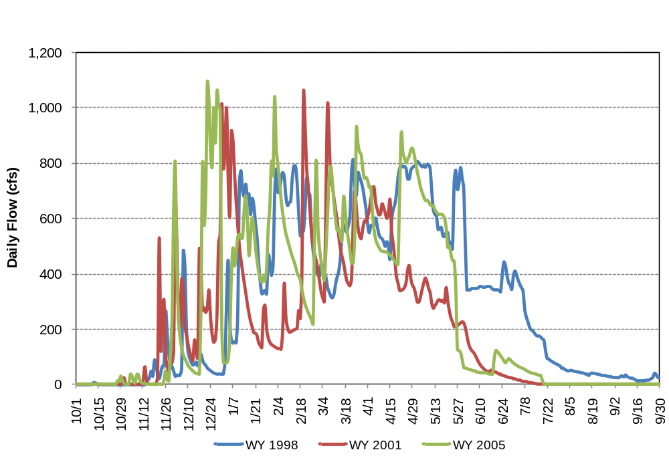
Figure 3.2-2. Mean daily flows in Camptonville Diversion Tunnel in representative Normal (2005), Wet (1998) and Dry (2001) water years.
As described above, the fish community potentially affected by entrainment into the Lowman Ridge Diversion Tunnel Intake is a transition fishery with no special-status, ESA-listed or CESA-listed fishes with the possible exception of hardhead (CSC). Little information is known concerning the potentially-affected fish community in Oregon Creek, but the fish community is likely composed of the same fish as near the Lohman Ridge Diversion Tunnel intake.

While the two tunnels generally do not divert water from around mid July through October, significant amounts of water are diverted at other times of the year. Given the volume of water diverted by the two intakes, the potential for fish to be entrained is high when the diversions occur, which could affect local fish populations.

4.0 Study Goals and Objectives

The objective of this study is to gather the information necessary to address the study goal which includes:
1. Characterize project facilities (diversions, intake structures and intakes, powerhouse turbines) and operations in relation to factors that may affect entrainment or mortality.
2. Develop the information necessary to assess the feasibility of screening intake structures (technical feasibility, feasibility level cost estimates, and maintenance requirements of screens.
3. Directly sample mortality and entrainment at selected project facilities, as designated by relicensing participants.

5.0 Study Methods and Analysis

5.1 Study Area

The study area includes the Middle Yuba River in the immediate vicinity of Our House Diversion Dam, Oregon Creek in the immediate vicinity of the Log Cabin Diversion Dam, New Colgate Power Tunnel intake, and Narrows 2 power tunnel intake.

If YCWA proposes an addition to the Project, the study area will be expanded if necessary to include areas potentially affected by the addition.

Licensees will obtain all necessary permits prior to performing fieldwork.

5.2 General Concepts

The following general concepts and practices apply to the study:

- Personal safety is the most important consideration of each fieldwork team.
- Licensee will make a good faith effort to obtain permission to access private property where needed well in advance of entering the property.
- Field crews may make minor variances to the FERC-approved study in the field to accommodate actual field conditions and unforeseen problems. When minor variances are made, Licensee’s field crew will follow the protocols in the FERC-approved study.
- When Licensee becomes aware of major variances to the FERC-approved study, Licensee will issue an e-mail to the Relicensing Contact List describing the variance and reason for the variance. Licensee will contact by phone the Forest Service (if the variance is on National Forest System land), USFWS, SWRCB and CDFG to provide an opportunity for input regarding how to address the variance. Licensee will issue an e-mail to the Relicensing Contact List advising them of the resolution of the variance. Licensee will summarize in the final study report all variances and resolutions.
- Licensee’s performance of the study does not presume that Licensee is responsible in whole or in part for measures that may arise from the study.
- Global Positioning System (GPS) data will be collected using either a Map Grade Trimble GPS (sub-meter data collection accuracy under ideal conditions), a Recreation Grade Garmin GPS unit (3 meter data collection accuracy under ideal conditions), or similar units. GPS data will be post-processed and exported from the GPS unit into Geographic Information System (GIS) compatible file format in an appropriate coordinate system using desktop software. The resulting GIS file will then be reviewed by both field staff and Licensee’s relicensing GIS analyst. Metadata will be developed for deliverable GIS data sets.
- Licensee will provide training to field crews to identify [agencies to develop a short suggested standard species list to be included here in each study proposal assuming Licensee agrees with the list – Licensee 4/15/10] that may reasonably be encountered coincidently during the performance of this study. Training will include instructions in diagnostic features and habitat associations of the above species. Field crews will also be provided laminate identification sheets showing the above species compared to other common species that may be encountered. All incidental observations will be reported in the appropriate Licensee report (e.g., incidental observations of special-status fish recorded during fieldwork for the Special-Status Turtles – Western Pond Turtle Study will be reported in Licensee’s Stream Fish Populations Study report). The purpose of this effort is not to conduct a focus study (no effort in addition the specific field tasks identified for the specific study) or to make all field crews experts in identifying all species, but only to opportunistically gather data during the performance of the study.

- Field crews will be trained on and provided with materials (e.g. Quat) for decontaminating their boots, waders, and other equipment between study sites. Major concerns are amphibian chytrid fungus, and invasive invertebrates (e.g. zebra mussel, Dreissena polymorpha). This is of primary importance when moving: 1) between tributaries and mainstem reaches; 2) moving between basins (e.g. Middle Yuba River, Yuba River, North Yuba River); and 3) moving between isolated wetlands or ponds and river or stream environments.

5.3 Study Methods

The study methods will consist of the following efforts to assess entrainment at major intake structures within Our House Diversion Pool, Log Cabin Diversion Pool, and New Bullards Bar Reservoir:

- 5.3.1 Monitoring at Lohman Ridge Tunnel Intake and Camptonville Tunnel Intake

- At the Lohman Ridge Tunnel Intake and the Camptonville Tunnel Intake, the Licensee shall install one or more of the following fish monitoring systems: 1) a BioSonics-type echosounder; 2) a Didson-type acoustic camera; or 3) a Vaki-type fish counter with integral digital video camera. The system(s) shall monitor for entrainment into the respective tunnels from April 15, or as soon as weather permits, through August 15 to determine the number and size of fish entrained. The Licensee shall analyze the fish monitoring data for each day of the April 15 through August 15th period. If the monitoring system does not cover the entire cross section of the intake, the data from the area covered shall be extrapolated on a straight proportional basis (i.e., no weighting) to estimate fish movement for the entire intake cross-section. Based on the data for each intake, the Licensee shall calculate the total number of fish entrained over the entire April 15 through August 15th monitoring period.

- The Licensee shall discuss the monitoring results with the Relicensing Participants, and the entire record will be retained and provided to Relicensing Participants in its raw form upon request. Prior to deployment of the monitoring system(s), the License shall invite interested Relicensing Participants to one 1-day meeting to provide information such as installation configuration and location and data reading protocols.

- Licensees shall perform a quality control/quality assurance review of all data, including maps, recordings, identifications and sightings.

- 5.3.2

- Single Beam Sonar in New Bullards Bar Reservoir

- Licensee will take single beam sonar readings from a boat in New Bullards Bar Reservoir in early June, twice between late June and early August, and once between September and early October. The readings will be taken along four, 200-meter-long transects near the New Colgate Tunnel intake. Each transect will be traversed over the course of an hour, and each of the four transects will be sampled during the day and again during the night.

5.3.3 QA/QC and Analyze Data

- Licensee will perform a quality control/quality assurance review of all data, including maps, recordings, identifications and sightings. The sonar fish tracking data will be analyzed in combination with the results of Licensee’s Stream Fish Populations Study data to assess the potential for effects to rainbow trout stream populations due entrainment into the two diversion tunnels.

5.3.4 Prepare Report

Licensee will prepare a report that includes the following sections for both study efforts: 1) Study Goals and Objectives; 2) Methods and Analysis; 3) Results; 4) Discussion; and 5) Description of Variances from the FERC-approved study proposal, if any.

For all special-status fish observations, Licensee will complete and file the appropriate California Natural Diversity Database form.

6.0 Study-Specific Consultation

- This study does not include any specific consultation unless the target number of fish can not be collected at each impoundment. In that case, Licensee will consult with CDFG regarding using hatchery fish to supplement the collected fish to perform the study.
- Agencies to develop preferred methodologies in collaboration with licensee and relicensing participants.

7.0 Schedule

Licensee anticipates the schedule to complete the study as follows assuming the PAD is filed on November 1, 2010, and FERC issues its Study Determination by October 4, 2011:

- Install monitoring devices at Lohman & Camptonville Tunnel Intake structures and implement monitoring effort………………………………..…April 15 – August 15 2012

Single Beam Sonar Study at New Colgate Intake June - October 2012
QA/QC and Analyze Data August-September 2012
Prepare Report September – October 2012

8.0 Consistency of Methodology with Generally Accepted Scientific Practices

This study is consistent with the goals, objectives, and methods outlined for recent FERC hydroelectric relicensing efforts in California..

9.0 Level of Effort and Cost

[Relicensing Participants – Licensee will include a cost range estimate for this study in its Proposed Study Plan. Licensee]

10.0 References Cited

California Department of Fish and Game (CDFG). 1974. A Summary of CDFG Fish Survey Results for the Bullards Bar Reservoir 1959 –1974. California Department of Fish and Game. Unpublished internal memo.

_____. 1989. A Summary of CDFG Fish Planting in the Bullards Bar Reservoir 1980 – 1989. Unpublished internal report.

_____. 2007. Fish Stocking Records for the Bullards Bar Reservoir, Englebright Reservoir, South Fork Yuba and Bear River 1950-2007. California Department of Fish and Game. Unpublished internal records.

Central Valley Fish Hatchery. 1959. A Survey of the Fish Population of Bullards Bar reservoir, Yuba County, 1959. Unpublished internal report.

Gast et al. 2005. Middle and South Yuba rainbow trout (Onchorhynchus mykiss) distribution and abundance dive counts August 2004. Included as Appendix G of CDWR 2006.

Nevada Irrigation District (NID) and Pacific Gas & Electric Company (PG&E). 2010. Technical Memorandum 3-1: Steam Fish Populations Study. 60 pp. Available online: <http://www.eurekasw.com/NID/Technical%20Memoranda/Forms/AllItems.aspx?RootF older=%2fNID%2fTechnical%20Memoranda&View=%7bEA33DA8A%2d6FAE%2d44 99%2d8D50%2dC8FC5921A996%7d>

Moore, A., I.C. Russell, and E.C.E. Potter. 1990a. The effects of intraperitoneally implanted dummy acoustic transmitters on the behaviour and physiology of juvenile Atlantic salmon, Salmo salar. J. Fish Biol. 37: 713-721.

Moore, A., I.C. Russell, and E.C.E. Potter. 1990b. Preliminary results from the use of a new technique for tracking the estuarine movements of Atlantic salmon, Salmo salar L., smolts. Aquaculture and Fisheries Management 21: 369-371.

Shroyer, S., and D. Logsdon. 2009. Detection distances of selected radio and acoustic tags in Minnesota Lakes and Rivers. North American Journal of Fisheries Management. 29: 876-884

Yuba County Water Authority (YCWA). 2009. Yuba River Development Project Relicensing Preliminary Summary

From 2005 through 2009, the Our House Diversion Dam Low-Level Auxiliary Intake has been exercised (i.e., tested during which the gates are quickly opened and closed) four times (i.e., March 23, April 10 and May 19, 2005; and January 3, 2006), and open for 200 days beginning on January 13, 2006, during which, with the approval of FERC, the Forest Service, CDFG and SWRCB Licensee removed sediment from Our House Diversion Dam Impoundment. Since 2005, the Log Cabin Diversion Dam Low-Level Auxiliary Intake has been exercised once (i.e., March 23, 2005), and was open for 19 days beginning on May 28, 2007. [Relicensing Participants – We will insert the frequency at which the New Bullards Bar Dam Low-Level Outlet was used in the past 5 years here in the next draft. Licensee]
A transition fishery is one that includes both coldwater and warmwater fishes and is typically found in the Sierra in lower elevations where the fish community transitions from a coldwater fishery dominated by trout in the higher elevations to a warm water fishery in the lower elevations.

